@ 2 OBERGESCHOSS
...
N

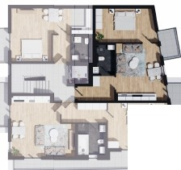

..(,.,- - --_

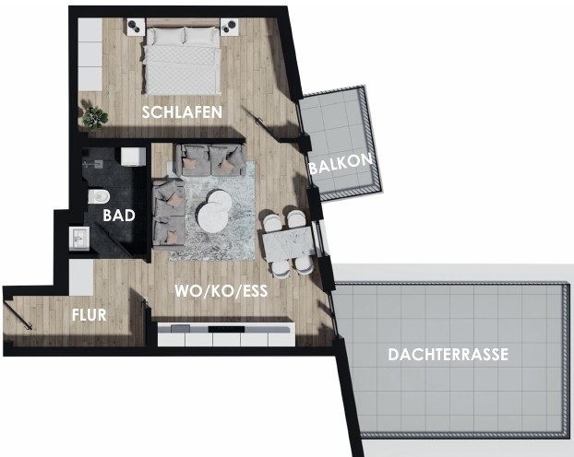

WOHNUNG NQ7
FLUR | 5.81 m2
BAD  WO/KO/ESS | 4.46 m2  19.05 m2
BALKON | 2.05 m2
DACHTERRASSE | 10.45 m2
SCHLAFEN | 13.55 m2

concept by DES!GNSOLUT!ONS

