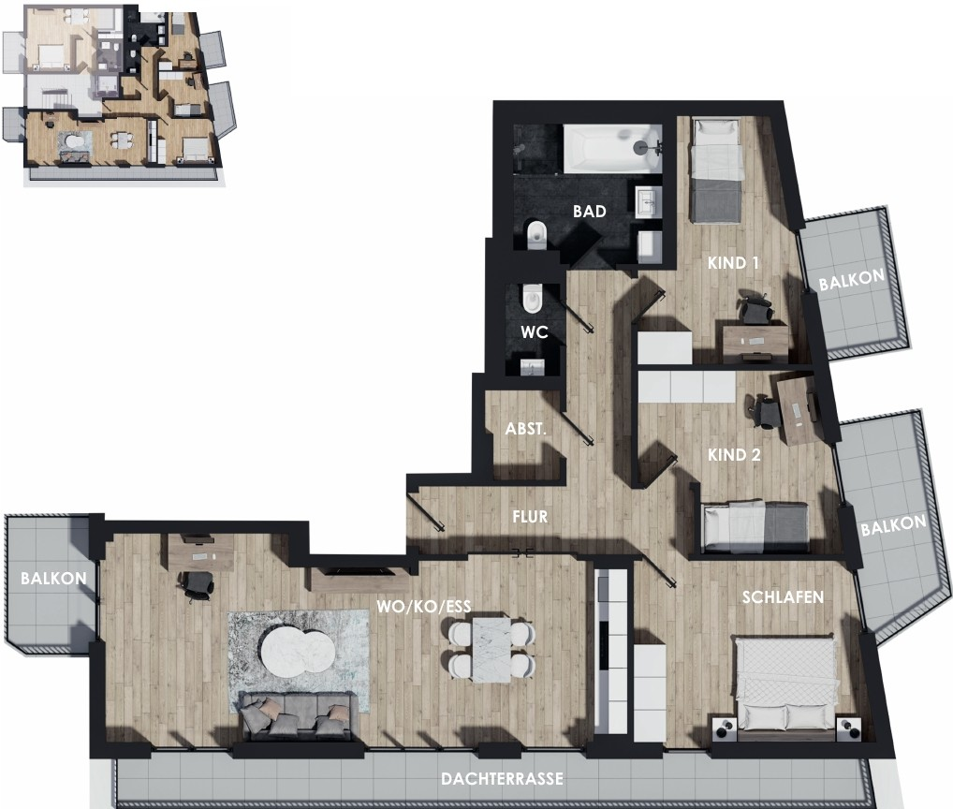
N -
@ DACHGESCHOSS
WOHNUNG NQ9
FLUR | 11.05 m2
ABST.  WC | 2.15 m2  1.86 m2
BAD | 5.95 m2
KIND 1 | 9.57 m2
BALKON | 1.94 m2
KIND 2 | 10.12 m2
BALKON | 2.83 m2
SCHLAFEN | 13.82 m2
WO/KO/ESS | 33.24 m2
DACHTERRASSE | 6.60 m2
BALKON | 1.69 m2

concept by DES!GNSOLUT!ONS

