@ 1 OBERGESCHOSS
N
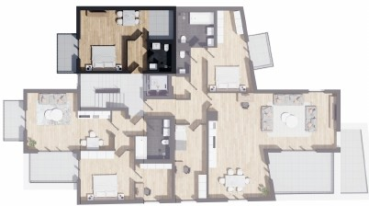

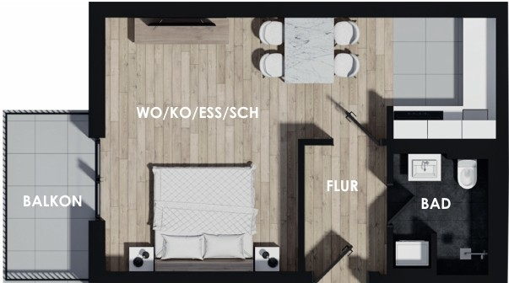

WOHNUNG NQS
FLUR | 3.46 m2
BAD  WO/KO/ESS/SCH | 3.92 m2  25.09 m2
BALKON | 2.19 m2

concept by DES!GNSOLUT!ONS

