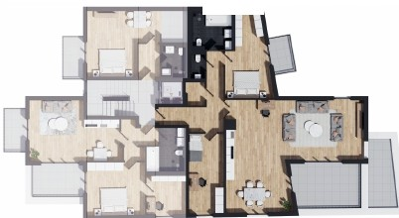
@
1 OBERGESCHOSS-
N
WOHNUNG NQ4
FLUR | 11.80 m2
ABST.  WC | 2.15 m2  1.86 m2
BAD | 5.95 m2
SCHLAFEN | 14.63 m2
BALKON | 3.88 m2
WO/KO/ESS | 57.34 m2
DACHTERRASSE | 7.50 m2
KIND 1 | 13.76 m2

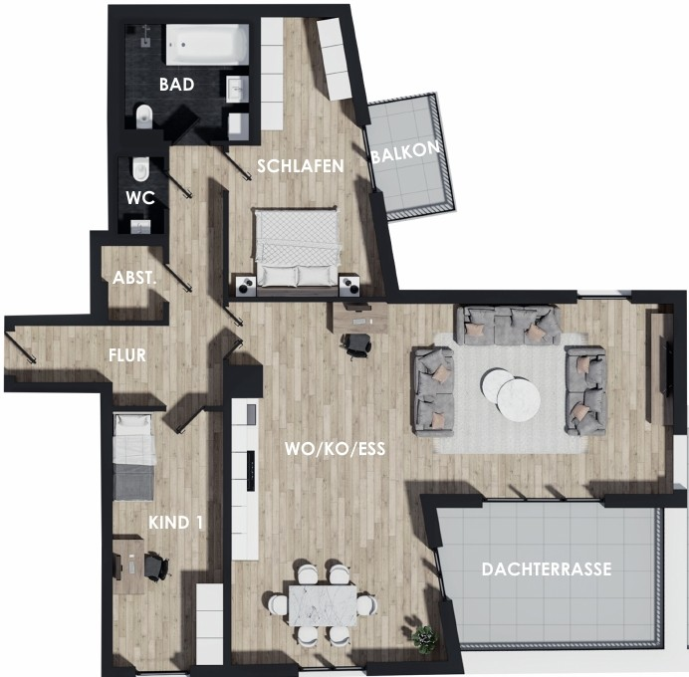
concept by DES!GNSOLUT!ONS

